

SAVEETHA SCHOOL OF ENGINEERING
SAVEETHA INSTITUTE OF MEDICAL AND TECHNICAL SCIENCES
CHENNAI-602105

Assignment
On
HOSPITAL MANAGEMENT SYSTEM USING JAVA
Submitted in the partial fulfilment for the award of the degree
of
BACHELOR OF ENGINEERING IN COMPUTER SCIENCE ENGINEERING
Submitted by
SANJAY KUMAR SOY (192311151)
CSA0907 – PROGRAMMING IN JAVA
Under the Supervision of
Dr. A.Mohan

SIMATS ENGINEERING
Saveetha Institute of Medical and Technical Sciences
Chennai – 602105
September 2026

TABLE OF CONTENTS
S. No. | Contents | Page No.
1 | Title | 2
2 | Problem Statement | 2
3 | Source Code | 2
3.1 | Project Overview | 2
3.2 | Package Structure | 3
3.3 | Classes and Objects | 4
3.4 | Inheritance and Polymorphism | 5
3.5 | Method Overloading | 5
3.6 | Interfaces | 5
3.7 | Collection Framework | 5
3.8 | Exception Handling | 6
3.9 | Multithreading and Synchronization | 6
3.10 | AWT and Event Handling | 6
3.11 | Java I/O and Serialization | 7
3.12 | JDBC Database Connectivity | 7
3.13 | Source Code | 7
4 | Test Cases and Validation | 7
4.1 | Validation of Appointment Conflict | 9
4.2 | Validation of Exception Handling | 9
4.3 | Validation of Database Operations | 10
4.4 | Validation of Concurrent Operations | 10
4.5 | Overall Test Result | 10
5 | Result / Output Screenshots | 10
5.1 | Main Hospital Management System Interface | 10
5.2 | Patient Registration | 11
5.3 | Doctor Management | 11
5.4 | Appointment Booking | 11
5.5 | Appointment Conflict Handling | 11
5.6 | Medical Record Management | 11
5.7 | Billing | 11
5.8 | Pharmacy Management | 11
5.9 | Database Output | 11
5.10 | Concurrent Appointment Booking Output | 12
5.11 | Overall Result | 12
6 | References | 12
7 | Individual Contribution – One Page | 13

1. Title
HOSPITAL MANAGEMENT SYSTEM USING JAVA
2. Problem Statement
A multi-specialty hospital handles a large volume of information related to patients, doctors, nurses, appointments, medical records, billing, and pharmacy services. Managing these activities manually or through separate systems can lead to data duplication, appointment conflicts, billing errors, difficulty in retrieving medical records, and delays in hospital operations. Furthermore, multiple hospital staff members may need to access and update the same information simultaneously, making data consistency and reliable processing important requirements.
The proposed Hospital Management System is a Java-based application designed to provide a centralized platform for managing major hospital operations. The system manages patient registration, doctor details, appointment scheduling, medical records, billing, and pharmacy services through an integrated application.
The system applies Java programming concepts such as classes and objects, inheritance, polymorphism, method overloading, packages, and interfaces to model different hospital entities and user roles. The Collection Framework, including ArrayList, HashSet, HashMap, generics, and iterators, is used to efficiently manage and retrieve application data. Built-in and user-defined exception handling mechanisms are incorporated to handle invalid patient information, unavailable doctors, appointment conflicts, invalid billing details, and other exceptional situations.
Since multiple staff members may perform operations concurrently, multithreading and synchronization are used to manage simultaneous requests and prevent inconsistent data. Inter-thread communication and thread priorities can be applied where required to coordinate concurrent hospital operations. An AWT-based graphical user interface provides forms and controls for patient registration, appointment booking, billing, and record management.
Java I/O streams and serialization are used for storing and retrieving suitable objects, while JDBC provides connectivity between the Java application and a relational database. Database operations such as insertion, updating, deletion, and retrieval are performed for important hospital records.
The primary objective of the system is to develop a reliable and efficient prototype that demonstrates the application of core Java concepts to a real-world hospital environment. The system is designed to minimize data inconsistencies, prevent appointment conflicts, improve information accessibility, and provide a foundation that can be further extended for use in a larger multi-specialty hospital.
3. Source Code
3.1 Project Overview
The Hospital Management System is developed using Java and follows an object-oriented, modular architecture. The application is divided into multiple packages so that different functionalities can be developed and maintained independently. The system uses Java AWT for the graphical user interface, JDBC for database connectivity, Java Collections for temporary data management, exception handling for error management, and multithreading with synchronization for concurrent operations.
The major modules of the system are:
- Patient Management
- Doctor Management
- Appointment Management
- Medical Record Management
- Billing Management
- Pharmacy Management
- User Management
- Database Management
- Exception Handling
- Multithreading and Synchronization
- Graphical User Interface
3.2 Package Structure
The project is organized into the following packages:
hospitalmanagement
│
├── model
│ ├── User.java
│ ├── Patient.java
│ ├── Doctor.java
│ ├── Nurse.java
│ ├── Appointment.java
│ ├── MedicalRecord.java
│ ├── Bill.java
│ └── Medicine.java
│
├── interfaces
│ ├── Billable.java
│ └── DatabaseOperations.java
│
├── exceptions
│ ├── InvalidPatientException.java
│ ├── DoctorUnavailableException.java
│ ├── AppointmentConflictException.java
│ └── InvalidBillingException.java
│
├── database
│ └── DBConnection.java
│
├── services
│ ├── PatientService.java
│ ├── DoctorService.java
│ ├── AppointmentService.java
│ ├── BillingService.java
│ └── PharmacyService.java
│
├── threads
│ ├── AppointmentBookingThread.java
│ ├── PatientRegistrationThread.java
│ └── BillingThread.java
│
└── ui
└── HospitalManagementGUI.java
3.3 Classes and Objects
The system uses classes to represent real-world hospital entities. Objects of these classes are created during program execution.
The major classes include:
- Patient – stores patient identification and personal information.
- Doctor – stores doctor details, specialization, and availability.
- Nurse – represents hospital nursing staff.
- Appointment – stores appointment date, time, patient, and doctor information.
- MedicalRecord – maintains diagnosis, treatment, and prescription details.
- Bill – stores billing information and payment details.
- Medicine – maintains pharmacy and medicine information.
- User – acts as a common parent class for different hospital users.
3.4 Inheritance and Polymorphism
Inheritance is used to avoid duplication of common user information. A common User class contains properties such as user ID, name, contact information, and login details. Classes such as Doctor, Nurse, and Receptionist can inherit these properties.
Polymorphism is implemented through method overriding. Different user types can provide their own implementation of methods such as displaying user details or performing role-specific operations.
3.5 Method Overloading
Method overloading is used when the same operation needs to be performed with different parameters. For example, billing calculations can be implemented using different methods depending on whether consultation charges, medicine charges, or additional service charges are provided.
Example:
calculateBill(double consultationCharge);

calculateBill(double consultationCharge, double medicineCharge);

calculateBill(double consultationCharge,
double medicineCharge,
double serviceCharge);
3.6 Interfaces
Interfaces are used to define common operations that can be implemented by different classes.
For example, a Billable interface can define billing-related operations, while a DatabaseOperations interface can define common database operations such as insert, update, delete, and retrieve.
3.7 Collection Framework
The Java Collection Framework is used to temporarily store and manage hospital information.
- ArrayList – used for maintaining lists of patients, doctors, and appointments.
- HashSet – used where duplicate values should not be allowed.
- HashMap – used for fast retrieval using unique identifiers such as patient ID or doctor ID.
- Generics – used to provide type safety in collections.
- Iterator – used to traverse collection elements.
Example:
ArrayList<Patient> patients = new ArrayList<>();

HashSet<String> doctorIds = new HashSet<>();

HashMap<String, Doctor> doctors = new HashMap<>();
3.8 Exception Handling
Exception handling is implemented to prevent abnormal program termination and provide meaningful error messages.
Built-in exceptions such as SQLException, NumberFormatException, and IOException are handled where appropriate.
User-defined exceptions are created for hospital-specific situations such as:
- Invalid patient information
- Doctor unavailable
- Appointment conflict
- Invalid billing information
This ensures that invalid operations are rejected safely.
3.9 Multithreading and Synchronization
Multithreading is used to simulate simultaneous operations performed by multiple hospital staff members. For example, two receptionists may attempt to book the same doctor at the same time.
Synchronization is applied to the appointment-booking operation. The system checks doctor availability inside a synchronized section before confirming an appointment. This prevents two threads from successfully booking the same doctor and time slot.
Thread priorities can also be assigned to important operations, while wait() and notify() can be used for communication between threads when required.
3.10 AWT and Event Handling
Java AWT is used to develop the graphical user interface. The interface contains components such as:
- Frame
- Panel
- Label
- TextField
- Button
- Choice
- Checkbox
- Menu
- MenuItem
Event listeners are used to perform actions when users interact with buttons, menus, and other controls.
3.11 Java I/O and Serialization
Java I/O streams are used to store and retrieve information from files. Serialization is used for suitable objects such as patient or medical record objects.
Objects implementing the Serializable interface can be converted into a byte stream and stored for later retrieval.
3.12 JDBC Database Connectivity
JDBC is used to connect the Java application with a relational database. The database stores persistent hospital information.
The system performs the following operations:
- INSERT – register new patients, doctors, appointments, and bills.
- SELECT – retrieve existing records.
- UPDATE – modify patient, doctor, appointment, and billing information.
- DELETE – remove records when required.
The JDBC workflow consists of establishing a database connection, preparing SQL statements, executing queries, processing results, and closing database resources.
3.13 Source Code
The complete source code of the Hospital Management System is included in the project repository and is provided in text format as part of the submission. The source code demonstrates the required Java concepts and provides the implementation of the hospital management modules.
4. Test Cases and Validation
The Hospital Management System was tested using different test cases to verify the correctness, reliability, data consistency, and proper handling of exceptional conditions. The testing covered patient registration, doctor management, appointment booking, medical records, billing, pharmacy operations, database operations, and concurrent requests.
Test Case ID | Test Scenario | Test Input | Expected Result | Actual Result | Status
TC01 | Patient Registration | Valid patient details | Patient should be registered successfully | Patient registered successfully | Pass
TC02 | Invalid Patient Registration | Empty/invalid patient details | System should reject the registration | Invalid details rejected | Pass
TC03 | Doctor Registration | Valid doctor details | Doctor should be added to the system | Doctor added successfully | Pass
TC04 | Doctor Search | Valid Doctor ID | Doctor details should be displayed | Doctor details displayed | Pass
TC05 | Appointment Booking | Available doctor and time slot | Appointment should be booked | Appointment booked successfully | Pass
TC06 | Appointment Conflict | Same doctor, date and time | System should reject duplicate booking | Booking rejected | Pass
TC07 | Unavailable Doctor | Doctor marked unavailable | Appointment should not be allowed | Appointment rejected | Pass
TC08 | Medical Record Entry | Valid patient and medical details | Record should be stored | Medical record stored | Pass
TC09 | Invalid Billing | Negative/invalid billing amount | System should display billing error | Invalid billing rejected | Pass
TC10 | Bill Generation | Valid patient and charges | Total bill should be calculated correctly | Bill generated successfully | Pass
TC11 | Pharmacy Request | Medicine available in stock | Medicine should be issued and stock updated | Medicine issued successfully | Pass
TC12 | Pharmacy Request | Medicine unavailable | Request should be rejected | Request rejected | Pass
TC13 | Database Retrieval | Existing patient ID | Patient information should be retrieved | Patient details retrieved | Pass
TC14 | Database Update | Modified patient details | Existing record should be updated | Record updated successfully | Pass
TC15 | Database Delete | Valid patient record | Record should be deleted | Record deleted successfully | Pass
TC16 | Concurrent Appointment Booking | Two threads booking same slot | Only one booking should succeed | One booking succeeded, other rejected | Pass
TC17 | Concurrent Billing | Multiple billing requests | Each transaction should be processed consistently | Transactions processed correctly | Pass
TC18 | File/Serialization Test | Serialized patient object | Object should be stored and retrieved | Object retrieved successfully | Pass
4.1 Validation of Appointment Conflict
Appointment booking is one of the most important validation scenarios. When multiple users attempt to book the same doctor for the same date and time, the system checks the existing appointment records before confirming the booking.
If the appointment slot is already occupied, the system throws an AppointmentConflictException and prevents the second booking.
For simultaneous requests, synchronization ensures that the appointment validation and booking operation are treated as a critical section. Therefore, only one thread can successfully reserve the available slot.
4.2 Validation of Exception Handling
The system validates invalid inputs and exceptional conditions using both built-in and user-defined exceptions. Examples include invalid patient information, unavailable doctors, duplicate appointments, invalid billing amounts, database errors, and file-handling errors.
Instead of terminating the application, the system displays an appropriate error message and allows the user to continue using the application.
4.3 Validation of Database Operations
JDBC-based database operations were tested using insertion, retrieval, updating, and deletion of hospital records. The results were checked against the records stored in the relational database to ensure that the application and database remain consistent.
4.4 Validation of Concurrent Operations
Concurrent operations were tested by creating multiple threads that attempted to access shared hospital resources. Synchronization was used to protect critical operations such as appointment booking and billing.
The test confirmed that simultaneous requests do not result in duplicate appointments or inconsistent shared data.
4.5 Overall Test Result
The test cases demonstrate that the Hospital Management System successfully performs its major operations and handles invalid and concurrent requests appropriately. The system maintains data consistency, prevents appointment conflicts, and provides reliable processing of hospital transactions.
5. Result / Output Screenshots
The developed Hospital Management System was successfully implemented as a Java-based application. The system provides a graphical interface for managing patients, doctors, appointments, medical records, billing, and pharmacy services.
The following screenshots demonstrate the execution and output of the developed system.
5.1 Main Hospital Management System Interface
The main interface provides access to the different modules of the Hospital Management System, including patient management, doctor management, appointment management, medical records, billing, and pharmacy services.
Figure 5.1: Main Hospital Management System Interface
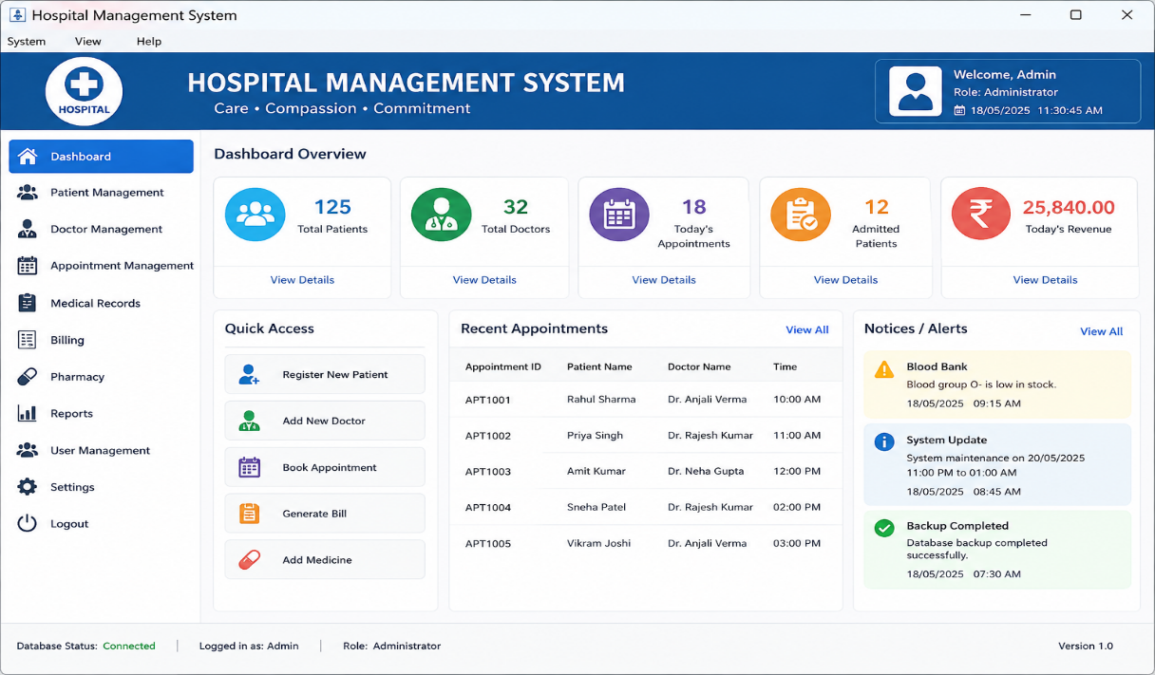
5.2 Patient Registration
The patient registration interface allows hospital staff to enter and store patient information such as patient ID, name, age, gender, contact number, address, and other relevant details.
Figure 5.2: Patient Registration Interface
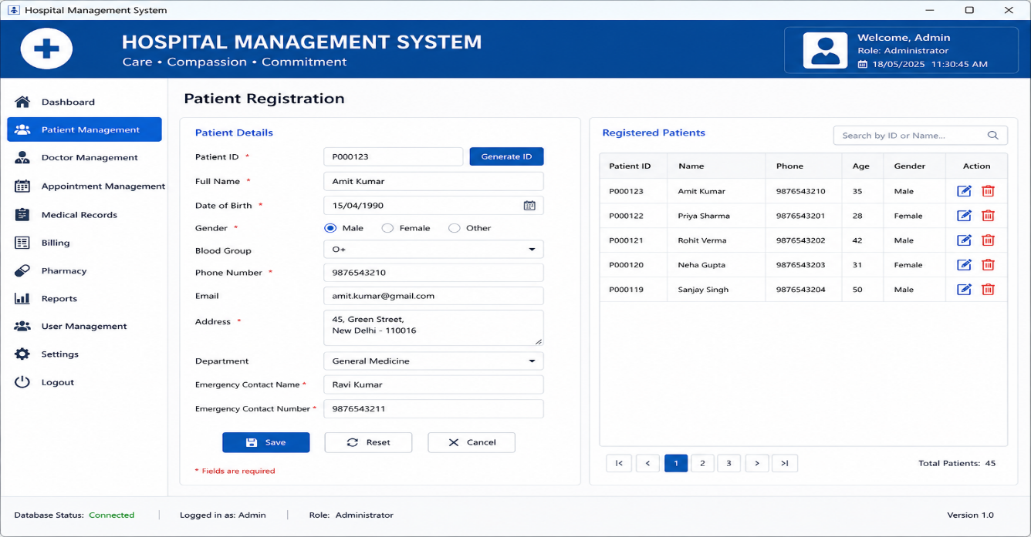
5.3 Doctor Management
The doctor management interface allows staff to add and manage doctor information, including doctor ID, doctor name, specialization, department, and availability.
5.4 Appointment Booking
The appointment module allows hospital staff to select a patient, doctor, date, and time and book an appointment after checking doctor availability.
5.5 Appointment Conflict Handling
When two users attempt to book the same doctor for the same date and time, the system prevents the duplicate appointment and displays an appropriate error message.
5.6 Medical Record Management
The medical record module allows authorized hospital staff to store and retrieve patient diagnosis, treatment, prescription, and other medical information.
5.8 Pharmacy Management
The pharmacy module manages medicine availability, issue requests, and stock updates. When medicine is issued, the corresponding stock quantity is updated.
5.9 Database Output
The database contains persistent records for patients, doctors, appointments, medical records, billing information, and pharmacy data. JDBC is used to perform insertion, retrieval, updating, and deletion operations.
5.10 Concurrent Appointment Booking Output
The concurrent booking test demonstrates the use of multithreading and synchronization. When two threads attempt to book the same doctor and time slot simultaneously, synchronization ensures that only one request is successfully processed while the other request is rejected due to an appointment conflict.
5.11 Overall Result
The Hospital Management System successfully demonstrates the required Java programming concepts and provides functional modules for managing major hospital activities. The application handles patient and doctor information, appointment scheduling, medical records, billing, and pharmacy operations while maintaining data consistency during concurrent operations.
The testing results show that valid operations are processed successfully and invalid or conflicting operations are handled using appropriate exception-handling mechanisms. The integration of AWT, Collections, Multithreading, I/O, Serialization, and JDBC demonstrates the practical application of Java concepts in a real-world hospital management scenario.
Yes. Since this is a Java programming assignment, you should include a References section at the end of the document. Keep it simple and use reliable sources.
References
- Herbert Schildt, Java: The Complete Reference, McGraw Hill Education.
- Cay S. Horstmann, Core Java: Fundamentals, Pearson Education.
- Oracle, Java Documentation – Java Platform, Standard Edition (Java SE). Available at: https://docs.oracle.com/en/java/
- Oracle, The Java Tutorials – Collections, Exceptions, I/O, and JDBC. Available at: https://docs.oracle.com/javase/tutorial/
- Oracle, Java Database Connectivity (JDBC) Documentation. Available at: https://docs.oracle.com/javase/tutorial/jdbc/
- Oracle, Java AWT and Event Handling Documentation. Available at: https://docs.oracle.com/javase/8/docs/api/java/awt/package-summary.html
- Oracle, Java Concurrency and Multithreading Documentation.

Individual Contribution – One Page
Name: Sanjay Kumar Soy
Role: Java Development and System Integration
I contributed to the development of the Hospital Management System by working on the design, implementation, and integration of the major modules of the application. My contribution focused on developing the Java-based system and ensuring that the different components worked together correctly.
I worked on the implementation of the patient and doctor management modules. The patient module provides functionality for registering patients, storing their details, updating information, and retrieving patient records. The doctor module maintains doctor details such as doctor ID, name, specialization, department, and availability. These modules were implemented using Java classes and objects following object-oriented programming principles.
I also contributed to the implementation of the appointment management functionality. The appointment module allows staff members to select a patient, doctor, date, and time and book an appointment. Appointment conflicts are checked before confirming a booking. Exception handling was implemented to handle situations such as unavailable doctors and duplicate appointment slots.
Java Collection Framework concepts were also applied in the project. ArrayList, HashSet, and HashMap were used for managing and retrieving patient, doctor, and appointment information. Generics were used to provide type safety, while iterators were used to traverse collection elements.
Another important part of my contribution was system integration. I worked with JDBC to connect the Java application to the relational database and perform CRUD operations. Patient, doctor, appointment, and billing information can be inserted, retrieved, updated, and deleted from the database.
I also participated in testing and validation of the application. Test cases were performed for valid and invalid patient registration, doctor availability, appointment conflicts, database operations, billing, and concurrent appointment requests. The results were analyzed to ensure that the system produced the expected output.
Through this project, I gained practical experience in Java object-oriented programming, packages, interfaces, collections, exception handling, multithreading, synchronization, AWT, JDBC, and database management. Working on the project also improved my understanding of software integration, debugging, testing, and collaborative development using GitHub.

